10.51: a) Solving Eq. (10.36) for 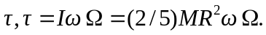 Using 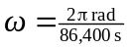 and 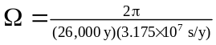and the mass and radius of the earth from Appendix F, 